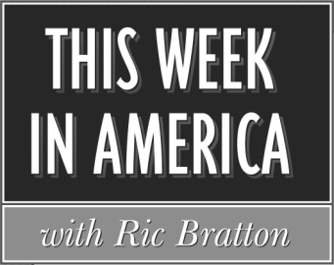

Program # 2018-44 1 Hour Version Cue Sheet
Airdate: Weekend of November 2-4, 2018
Producer: Sean Bratton Host: Ric Bratton (www.thisweekinamerica.us)

Blue Funk Broadcasting
c/o Production
11535 Leo Rd, Suite 3
Fort Wayne, IN 46845
Phone (260) 483-2116
Email production@bluefunkbroadcasting.com
Fax (888) 890-3292

Segment 1

Total runtime for segment: 29:30
Outcue: (music out)

LOCAL SPOT BREAK 3:00

Segment 2

Total runtime for segment: 19:15
Outcue: “that's (800) 659-5731”

LOCAL SPOT BREAK 1:00

Segment 3
Total runtime for segment: 5:15
Outcue: (music out)

