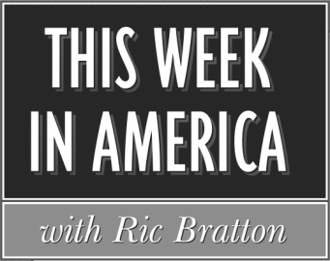

Program # 2020-40 1 Hour Version Cue Sheet
Airdate: Weekend of October 2-4, 2020
Producer: Sean Bratton Host: Ric Bratton (www.thisweekinamerica.us)

Blue Funk Broadcasting
c/o Production
121 Larchmont Terrace
Sebastian, FL 32958
Phone (772) 228-8130
Email production@bluefunkbroadcasting.com
Fax (888) 890-3292

Segment 1

Total runtime for segment: 29:30
Outcue: (music out)

LOCAL SPOT BREAK 3:00

Segment 2

Total runtime for segment: 18:00
Outcue: “that's (877) 360-0430”

LOCAL SPOT BREAK 1:00

Segment 3
Total runtime for segment: 6:30
Outcue: (music out)

