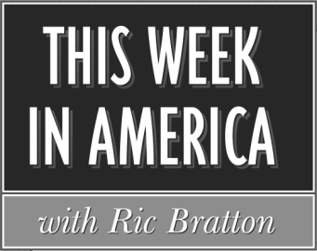

Program # 2025-37 1 Hour Version Cue Sheet
Airdate: Weekend of September, 5-7 2025
Producer: Sean Bratton Host: Ric Bratton (www.thisweekinamerica.us)

Blue Funk Broadcasting
c/o Production
121 Larchmont Terrace
Sebastian, FL 32958
Phone (772) 228-8130
Email production@bluefunkbroadcasting.com
Fax (888) 890-3292

Segment 1

Total runtime for segment: 29:30
Outcue: (music out)

LOCAL SPOT BREAK 3:00

Segment 2

Total runtime for segment: 16:15
Outcue: “that's (800) 263-2610”

LOCAL SPOT BREAK 1:00

Segment 3

Total runtime for segment: 8:15
Outcue: (music out)

