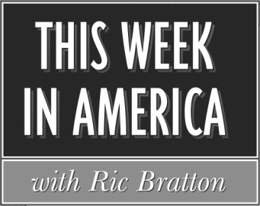

Affidavit for February 2022
Producer: Sean Bratton Host: Ric Bratton (www.thisweekinamerica.us)

Please sign and return by 3/21/22
Blue Funk Broadcasting
c/o Production
121 Larchmont Terrace
Sebastian, FL 32958
Phone (260) 483-2116
Email production@bluefunkbroadcasting.com
Fax (772) 228-8130

Show 2022-6 Airdate and time:_______________
Show 2022-7 Airdate and time:_______________
Show 2022-8 Airdate and time:_______________
Show 2022-9 Airdate and time:_______________

Advertiser Length

Low Cost Airlines :60
Tax Doctor :60

Low Cost Airlines :60
Tax Doctor :60
Home Security :60

(3rd spot break for 1 hr version)
Low Cost Airlines :60
Tax Doctor :60

Shows aired on dates indicated, including commercials

Name_______________________________________

Title________________________________________

Email_______________________________________

Station______________________________________

City and State________________________________

