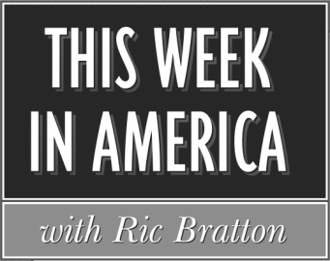

Affidavit for May 2020
Producer: Sean Bratton Host: Ric Bratton (www.thisweekinamerica.us)

Please sign and return by 6/20/20
Blue Funk Broadcasting
c/o Production
121 Larchmont Terrace
Sebastian, FL 32958
Phone (260) 483-2116
Email production@bluefunkbroadcasting.com
Fax (772) 228-8130

Show 2020-18 Airdate and time:_______________

Advertiser Length

Low Cost Airlines :60
Tax Helpline :60

Low Cost Airlines :60
Tax Help Line :60
Low Cost Airlines :60

(3rd spot break for 1 hr version)
Low Cost Airlines :60
Tax Help Line :60

Show 2020-19 Airdate and time:_______________
Show 2020-20 Airdate and time:_______________
Show 2020-21 Airdate and time:_______________
Show 2020-22 Airdate and time:_______________

Advertiser Length

Low Cost Airlines :60
Debt Destroyer :60

Debt Destroyer :60
Low Cost Airlines :60
Tax Help :60

(3rd spot break for 1 hr version)
Low Cost Airlines :60
Debt Destroyer :60

Shows aired on dates indicated, including commercials

Name_______________________________________

Title________________________________________

Email_______________________________________

Station______________________________________

City and State________________________________

